Holiday Sensations
Rhonda Mattson, MOTR/L, CHT
T

his time of year is wonderful; it is a time where we get to spend our free time with friends and family and along the way usually get to eat lots of food. But for many children this changing atmosphere is difficult to adjust too. Do you have a child that gets upset and throws tantrums when there are too many people around or when you cook, and the house starts to smell? This is not unusual, and in many cases can be worked on.
Let’s talk about the sensory systems first. Everyone knows the basics: sight, sound, smell, hearing, and taste; but did you know there are two more? The final two are the vestibular system (knowing where your head is in space) and your proprioceptive system (knowing where your body is in space). In future issues we will talk more about each system, but let’s focus on the primary five as they are the most easily identified and we are all familiar with them.
Most of us have normal sensory systems meaning when something changes our body adapts and we keep going as if nothing has happened however for many children they are unable to do this. Think about all the lights and changes that happen around the house. Do you put up a tree with lights, do you place decorations around your house that may glare or reflect light? Children who have difficulty with processing visually may become overstimulate with the change. They may not be able to process/screen out the extra light.
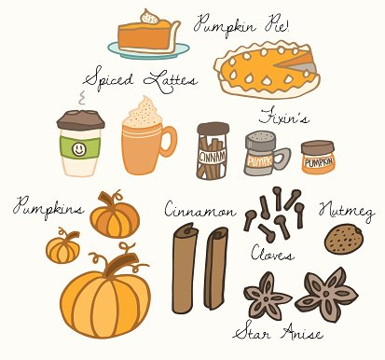
Do you play holiday music around the house when you normally wouldn’t have any noise, are you doing extra cleaning with the vacuum or hitting pots and pans around while you cook? Children may not be able to handle extra noise and screen this out causing a lack of focus and tantrums.
Are you cooking foods that you normally wouldn’t be? Many holiday foods have very strong smells and children that are already sensitive may start to have difficulty at these times, and when asked to taste these new foods may refuse and throw a fit. Smell is a huge part of our taste and if they are already overwhelmed with the smell they likely will not try a new food. This leads many children to have problems with eating new foods and they will have a very short list of what foods they will eat.
With all these sensory systems the result is typically the same. The child is seen as misbehaving and “throwing a fit”. Be aware and try to notice if there is a sight, smell, touch, etc. that may have set them off. Look for those moments where you think, I have no idea what set him off.
In upcoming newsletters, we will delve more into each system so that you get a clearer picture and to know exactly what to watch out for. In the meantime, if you have concerns please feel free to contact us or of course your pediatrician.

Holiday Play….and Work
Alyssa DeRoos, MS, CCC-SLP
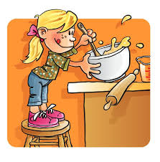

As the holiday season quickly approaches, we start to look forward too many exciting things including time with family, good food, gifts, and time off from school and/or work. The increase in family togetherness is a great time to spend with your children and help develop their language skills.
Nature walks are a great way to introduce new vocabulary concepts, as well as make “real world” connections. Go on a scavenger hunt and collect tree leaves, seeds, and bark. Discuss with your child about the different colors they see, textures they feel, and sounds they hear.
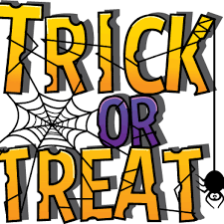
Trick-or-Treating nights are an excellent opportunity to work on social skills. Show your child how to smile or wave as they pass a familiar face, and how to look in the direction of the person giving them a treat to say, “Thank you”.
Thanksgiving is the perfect opportunity to have your child in the kitchen to assist with baking. Following a recipe works on following directions and basic concepts such as in, on, before, and/or after.
Not only are the holidays rich in language opportunities, but they provide an excellent source to work on speech abilities. Now, you may be wondering what is the difference between speech and language? Is there a different between speech and language? The answer is a surprising, yes!
Speech consists of the sounds we produce and how we sound when we are talking. Some children have a difficult time producing sounds correctly when they are speaking; often substituting one sound for another. For example, twick-oh-tweet, for trick-or-treat. Many parents and adults think this is “cute’, but it could be a sign of an articulation delay or disorder.
The holiday season provides for increased time to listen to your child and catch any errors they may be making on sounds. Common errors include “L”, “R”, “S”, and “TH”.
If you have questions or concerns about how your child sounds and if certain sounds are developmentally appropriate for your child, you can reach out to your pediatrician or the staff here at Zenith Rehabilitation. We would be happy to answer any questions or concerns regarding your child’s speech and/or language skills and development.

